REPORT TITLE

IE 401/402 SENIOR DESIGN PROJECT REPORT

BY

NAME SURNAME

UNIVERSITY OF TURKISH AERONAUTICAL ASSOCIATION
DEPARTMENT OF INDUSTRIAL ENGINEERING

January 2024

I hereby declare that all information in this document has been obtained and presented in accordance with academic rules and ethical conduct. I also declare that, as required by these rules and conduct, I have fully cited and referenced all material and results that are not original to this work.

Surname, Name :
Signature :

ABSTRACT

PROJECT TITLE

Surname, Name
Supervisor:
Co-Supervisor:

Abstract should be between 350-500 words.
January 1st, 2024.
Keywords: (Max. 5 keywords)

ÖZET

PROJE BAŞLIĞI

Soyadı, Adı
Danışman:
Eş Danışman (Varsa):

Özet 350-500 kelime arasında olmalıdır.
1 Ocak, 2024
Anahtar Kelimeler: (En fazla 5 anahtar kelime)

TABLE OF CONTENTS
ABSTRACT iii
ÖZET iv
TABLE OF CONTENTS v
LIST OF TABLES vi
LIST OF FIGURES vii
LIST OF ABBREVIATIONS viii
LIST OF SYMBOLS ix
1. INTRODUCTION 11
2. LITERATURE REVIEW 13
3. SOLUTION METHODOLOGY 15
CONCLUSION 17
REFERENCES 19

LIST OF TABLES
TABLES
Table ‎3.1: Results 16

LIST OF FIGURES
FIGURES
Figure ‎1.1: Training planes technical supports 11
Figure ‎1.2: Computer aided design lab 12
Figure ‎3.1: UTAA modern airplanes 15

LIST OF ABBREVIATIONS

ABBREVIATIONS
Remove this page if it is not necessary

LIST OF SYMBOLS

SYMBOLS
Remove this page if it is not necessary

1. INTRODUCTION
In this section, introduce your project content. The number of sub-sections can be increased or decreased. On the pages up to the “INTRODUCTION” section, page numbers should be shown in Roman numerals format (i, ii, iii, iv, v, vi, vii, viii, etc.).

Motivation of the Project
Use Times New Roman 12 punto and 1.5 line spacing in your report. Paragraphs should be justified. The titles of the main sections should be 14 punto and must be written in capital letters. The titles of the sub-sections should be 12 punto and the initial letters of the words should be written in capital letters. The titles of sub-sections in this template are just sample, so they can be changed. The titles of main sections should not be changed. Figure captions should be centerized.
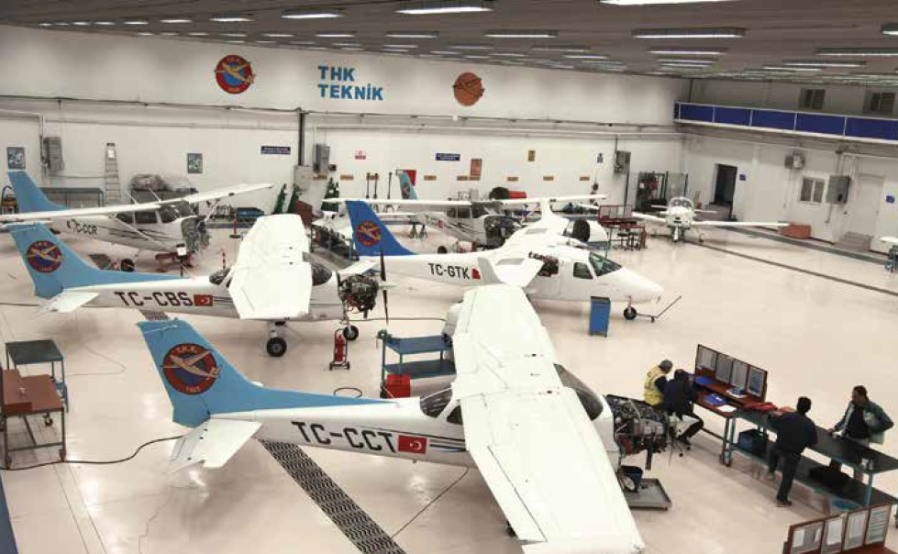
Figure ‎1.1: Training planes technical supports
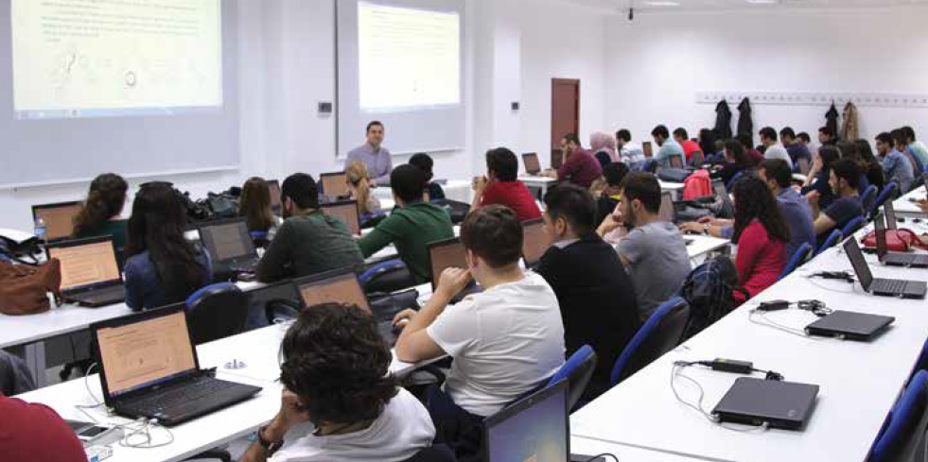
Figure ‎1.2: Computer aided design lab

Contributions
Add your contributions:
- Contribution-1
- Contribution-2
- Contribution-3, etc.

The Outline of the Project Report
Add the outline of your project report.

2. LITERATURE REVIEW
Use “IEEE Referencing Guide” in your report: IEEE Reference Style Guide for Authors.

Citing in the Text
Indicating the relevant reference in the text: A number enclosed in square brackets, eg.[1] or [26], placed in the text of the essay, indicates the relevant reference. Each reference number should be enclosed in square brackets on the same line as the text, before any punctuation, with a space before the bracket. Citations are numbered in the order in which they appear in the text and each citation corresponds to a numbered reference containing publication information about the source cited in the reference list at the end of the publication, essay or assignment. Once a source has been cited, the same number is used in all subsequent references. No distinction is made between print and electronic references when citing within the text. Here are some examples of this kind of referencing :
"...end of the line for my research [13]."
"The theory was first put forward in 1987 [1]." "Scholtz [2] has argued that......."
"Several recent studies [3, 4, 15, 16] have suggested that..."
"For example, see [7]."
It is not necessary to mention either the author(s) or the the date of the reference unless it is relevant to your text. It is not necessary to say " in reference [26] ..." "In [26] ..." is sufficient.
Citing more than one reference at a time: When citing more than one source at a time, the preferred method is to list each reference number separately with a comma or dash between each reference.
Preferred:
[1], [3], [5]
[1] - [5]
Although the following method is also acceptable:
Acceptable:
[1, 3, 5]
[1-5]
Citing a reference multiple times: When citing a source for a second or subsequent time, do not use ibid or op. cit. In the text, repeat the earlier reference number. If referring to a different page number, or other reference, within the source, use the following forms: [3, pp. 5-10], [3, Ch. 2, pp. 6-21], [3, Fig. 1], [3, Sec. 4.5]

Formatting the Reference List
The reference list should appear at the end of your paper. Begin the list on a new page. The title REFERENCES should be centered on the page.The hanging indent for each reference makes the numerical sequence more obvious. The entries should appear as one numerical sequence in the order that the material is cited in the text of your assignment.

3. SOLUTION METHODOLOGY
In this section of the report, there should be problem definition, proposed solution method(s) and the results.

3.1. Problem Definition
Mention your problem definition in this section.

Sub-Section
Add sub-sections, if it is necessary.
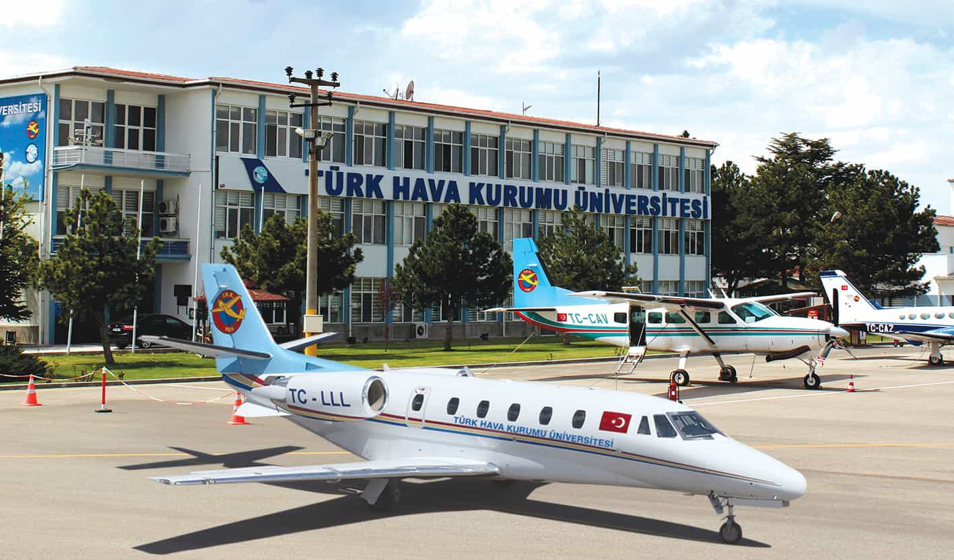
Figure 3.1: UTAA modern airplanes

Equations
Add equations in (Eq. 1), (Eq. 2), etc. format.
$$y_{k}=∅_{k}\left(X\right)+x_{k}$$ | (1)
$$y_{k}=x_{k}*P_{k}$$ | (2)

3.2. Results
Add your results in this section. Table captions should be centerized.
Table 3.1: Results
Country List
Country Name or Area Name | ISO ALPHA 2 Code | ISO ALPHA 3 Code | ISO numeric Code
Afghanistan  Albania  Algeria  American Samoa  Andorra  Angola | AF  AL  DZ  AS  AD  AO | ALA  ALB  DZA  ASM  AND  AGO | 248  008  012  016  020  024

CONCLUSION
This section should be between 250-450 words.

REFERENCES

Use “IEEE Referencing Guide” in end-text citation: IEEE Reference Style Guide for Authors.
The reference list should appear at the end of your paper. Begin the list on a new page. The title REFERENCES should be centered on the page.The hanging indent for each reference makes the numerical sequence more obvious. The entries should appear as one numerical sequence in the order that the material is cited in the text of your assignment.
Examples:
[1] A. Rezi and M. Allam, "Techniques in array processing by means of transformations, " in Control and Dynamic Systems, Vol. 69, Multidemsional Systems, C. T. Leondes, Ed. San Diego: Academic Press, 1995, pp. 133-180.
[2] G. O. Young, "Synthetic structure of industrial plastics," in Plastics, 2nd ed., vol. 3, J. Peters, Ed. New York: McGraw-Hill, 1964, pp. 15-64.
[3] M. M. Chiampi and L. L. Zilberti, “Induction of electric field in human bodies moving near MRI: An efficient BEM computational procedure,” IEEE Trans. Biomed. Eng., vol. 58, pp. 2787–2793, Oct. 2011, doi: 10.1109/TBME.2011.2158315.
[4] N. Osifchin and G. Vau, "Power considerations for the modernization of telecommunications in Central and Eastern European and former Soviet Union (CEE/FSU) countries," in Second Int. Telecommunications Energy Special Conf., 1997, pp. 9-16.
[5] D. Sarunyagate, Ed., Lasers. New York: McGraw-Hill, 1996.
[6] O. B. R. Strimpel, "Computer graphics," in McGraw-Hill Encyclopedia of Science and Technology, 8th ed., Vol. 4. New York: McGraw-Hill, 1997, pp. 279-283.
[7] K. Schwalbe, Information Technology Project Management, 3rd ed. Boston: Course Technology, 2004.
[8] M. N. DeMers, Fundamentals of Geographic Information Systems, 3rd ed. New York: John Wiley, 2005.
[9] L. Vertelney, M. Arent, and H. Lieberman, "Two disciplines in search of an interface: Reflections on a design problem," in The Art of Human-Computer Interface Design, B. Laurel, Ed. Reading, MA: Addison-Wesley, 1990. Reprinted in Human-Computer Interaction (ICT 235) Readings and Lecture Notes, Vol. 1. Murdoch: Murdoch Univ., 2005, pp. 32-37.
[10] E. P. Wigner, "Theory of traveling wave optical laser," Physical Review, vol.134, pp. A635-A646, Dec. 1965.
[11] J. U. Duncombe, "Infrared navigation - Part I: An assessment of feasibility," IEEE Transactions on Electron Devices, vol. ED-11, pp. 34-39, Jan. 1959.
[12] M. Bell, et al., Universities Online: A survey of online education and services in Australia, Occasional Paper Series 02-A. Canberra: Department of Education, Science and Training, 2002.
[13] T. J. van Weert and R. K. Munro, Eds., Informatics and the Digital Society: Social, ethical and cognitive issues: IFIP TC3/WG3.1&3.2 Open Conference on Social, Ethical and Cognitive Issues of Informatics and ICT, July 22-26, 2002, Dortmund, Germany. Boston: Kluwer Academic, 2003.
[14] I. S. Qamber, "Flow graph development method," Microelectronics Reliability, vol. 33, no. 9, pp. 1387-1395, Dec. 1993.
[15] Australia. Attorney-Generals Department. Digital Agenda Review, 4 Vols. Canberra: Attorney- General's Department, 2003.
[16] C. Rogers, Writer and Director, Grrls in IT. [Videorecording]. Bendigo, Vic.: Video Education Australasia, 1999.
[17] L. Bass, P. Clements, and R. Kazman. Software Architecture in Practice, 2nd ed. Reading, MA: Addison Wesley, 2003. [Online] Available: Safari e-book.
[18] D. Ince, "Acoustic coupler," in A Dictionary of the Internet. Oxford: Oxford University Press, 2001. [Online]. Available: Oxford Reference Online, http://www.oxfordreference.com. [Accessed: May 24, 2005].
[19] H. K. Edwards and V. Sridhar, "Analysis of software requirements engineering exercises in a global virtual team setup," Journal of Global Information Management, vol. 13, no. 2, p. 21+, April-June 2005. [Online]. Available: Academic OneFile, http://find.galegroup.com. [Accessed May 31, 2005].
[20] P. H. C. Eilers and J. J. Goeman, "Enhancing scatterplots with smoothed densities," Bioinformatics, vol. 20, no. 5, pp. 623-628, March 2004. [Online]. Available: www.oxfordjournals.org. [Accessed Sept. 18, 2004].
[21] A. Holub, "Is software engineering an oxymoron?" Software Development Times, p. 28+, March 2005. [Online]. Available: ProQuest, http://il.proquest.com. [Accessed May 23, 2005].
[22] H. Zhang, "Delay-insensitive networks," M.S. thesis, University of Waterloo, Waterloo, ON, Canada, 1997.
[23] “AlphaCom Communications introduces VMSK technology,” The Business Journal Online, May, 2000. [Online]. Available: http://www.business-journal.com/LateMay00/Alpha.html. [Accessed: May 2, 2000].
[24] J. Riley, "Call for new look at skilled migrants," The Australian, p. 35, May 31, 2005. Available: Factiva, http://global.factiva.com. [Accessed May 31, 2005].
[25] European Telecommunications Standards Institute, “Digital Video Broadcasting (DVB): Implementation guidelines for DVB terrestrial services; transmission aspects,” European Telecommunications Standards Institute, ETSI TR-101-190, 1997. [Online]. Available: http://www.etsi.org. [Accessed: Aug. 17, 1998].
[26] J. Geralds, "Sega Ends Production of Dreamcast," vnunet.com, para. 2, Jan. 31, 2001. [Online]. Available: http://nl1.vnunet.com/news/1116995. [Accessed Sept. 12, 2004].
[27] W. D. Scott & Co, Information Technology in Australia: Capacities and opportunities: A report to the Department of Science and Technology. [Microform]. W. D. Scott & Company Pty. Ltd. in association with Arthur D. Little Inc. Canberra: Department of Science and Technology, 1984.
[28] “A ‘layman’s’ explanation of Ultra Narrow Band technology,” Oct. 3, 2003. [Online]. Available: http://www.vmsk.org/Layman.pdf. [Accessed: Dec. 3, 2003].

APPENDICES
- Appendix Title
Add appendix here (if it is necessary)

- Appendix Title
Add appendix here (if it is necessary)
- Appendix Title
Add appendix here (if it is necessary)

